The Consume Message check box needs some discussion.

关于Consume Message 复选框的一些注解。

Within a BPD instance, a Message Start Event step can consume the message.

在一个BPD实例中，一个消息启动事件可以监听这个消息

This means that if there are other Message Start Event steps in the same process that are also listening for this same event, only one of them will be started.

意思是说，在同一个流程中如果有多个消息启动事件监听同一个事件，只有一个
消息启动事件被启动。

If the Consume Message check box is not checked, then all the Message Start Event steps for the same event will be started.

如果Consume Message 复选框没有被选中，同一个事件的多个消息启动事件都会被启动。

The Condition area is a JavaScript boolean valued expression which is a guard on whether an arriving event will be utilized by this process.

Condition 区域是一个JS Boolean 值表达式，用来判断是否让到达的事件通过这个流程。

The data passed with the event is available in the JavaScript name-space called tw.message.

获取数据可以通过JS 有效的事件中的名字空间tw.message。

A process can include multiple Message Start Events signifying multiple entry points into the same process. This is illustrated in the following diagram:

.一个流程包含多个消息启动事件意味着同一个流程可以有多个入口。
如下图所示。

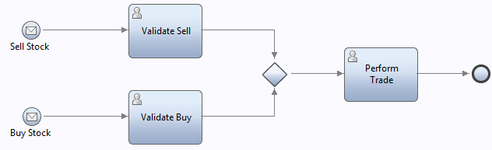
The BPD started when a UCA is fired is always the default process app assuming that multiple process app snapshots exist for the same solution.If a specific snapshot is to be used as the one in which the BPD is to be started, consider using the startBPDByName JavaScript function.

See also:
• Message Intermediate Event
• Modeling Event Sub-processes
• Undercover Agents (UCAs)
• Starting a UCA from REST
• Scenario - Asynchronously starting one process from another

在同一个环境里，有多个PA的snapshot,UCA总是触发默认PA的BPD。如果想指定一个snapshot的BPD启动，要使用JavaScript方法startBPDByName。
请参考：
• Message Intermediate Event
• Modeling Event Sub-processes
• Undercover Agents (UCAs)
• Starting a UCA from REST
• Scenario - Asynchronously starting one process from another

User Task

The User Task is a step in the BPD that is designed to be performed by a person.

在BPD中User Task 是一个用户执行的操作步骤。

The implementation of a User Task is always a Human Service.

通过调用一个Human Service 来实现 User Task.

A User Task is indicated by a human icon in the top left of the activity box:

在User Task 的左上角有一个人形的图标：

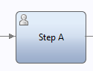
When a User Task is reached within the process, the process pauses its execution until the task created by this step is completed.

在一个流程里，当启动一个user task ，整个流程就会处于停顿状态，直到这个user task 创建的任务完成。

This could take some time and as such the process state is always written to database and the resources being used by the process released.

这会消耗一些时间，流程的状态会被写入数据库，同时这些被流程用到的资源将会被释放。

There can be far more process instances in the system waiting on User Tasks to complete than could be accommodated concurrently in memory.

与此同时，系统里可能会有很多的流程实例等待这个任务的完成而不是同时处理。

How a user works with these tasks is a separate story told in the Process Portal section.

用户如何在Process Portal中有一个单独的工作任务

The User Task has a number of associated properties.

User Task 有很多相关的属性

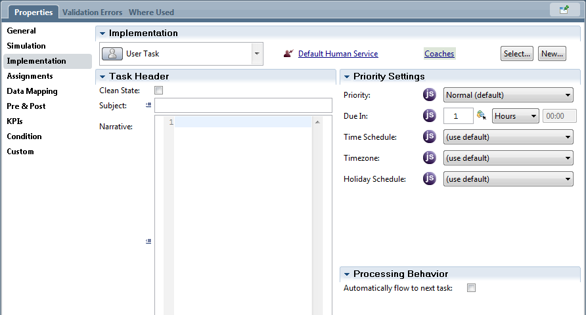

The Subject property of the activity allows us to enter a single line of text to act as a summary of the task.This becomes the title of the Human Task that is created.

Subject: 允许我们输入一行文本作为任务的总结，并作为被创建Human Task的标题。

The Narrative section is a description of the task. This is especially useful if the activity is a human service as this shows up in the Process Portal.

Narrative: Narrative 部分用来描述任务。这个在Process Portal显示人工服务的时候非常有用。

If HTML is added to the narrative, that HTML is displayed in the Process Portal and is interpreted.

如果HTML 添加一个叙述，那么这个HTML会在Process Portal显示并作为注解。

The Priority attribute associated a priority value with the task. This can be used by a task list interface to sort or otherwise visualize a list of tasks such that those with higher priority are shown first.

Priority属性的值与任务的优先级有关。它可以通过一个任务列表界面排序也可以按优先级从高到低排序。

优先级的值是这些值之一：

The value for Priority is one of:
• Lowest
• Low
• Normal
• High
• Highest

The system does not act upon these values directly. They are merely indicators to user interfaces such as the IBM BPM Process Portal

系统不能直接操作这些值。它们只是IBM BPM Process Portal用户界面的一个指标。

The Due In property defines a due date for when the task is expected to be completed.

Due In属性定义在任务完成的预期时间。

This due date becomes associated with the task such that user interfaces can guide the user on which tasks to work upon first.

这种到期日期变得与任务相关,这样用户界面可以引导用户的第一个工作任务。

It is presumed that those with the same priority but sooner due dates would most likely be the next ones to be handled.

据推测，如果两个任务的优先级相同但一个任务的预期时间更早，那么这个任务会先被执行。

The due date is calculated as the addition of a time interval to the time when the activity was started.

预期时间适合作为活动开始时的间隔时间。

Time intervals can be supplied as either hours, minutes or days or from a variable or JavaScript.

时间间隔可以是小时、分钟或天数的一个变量或JS脚本。

The Clean State property is documented in the InfoCenter (8.5) as the following:

下面是InfoCenter(8.5)中关于Clean State 属性的记录

Select Clean State if you want to clear the runtime execution state of an activity after it is
complete.

选中 Clean State 属性可以清除一个完成的活动在执行作态时的运行时间。

By default, this option is disabled. Enable this option only when you do not want to store
execution data (such as variable values) for viewing after the process finished execution

默认情况下，此选项是不选的。只有在一个可见的流程执行完成而你不想保存执行数据（如一个变量的值）得时候才选中此选项

It isn't quite clear when one would use this or what exactly it means.
See also:

• 人工服务

不确定在什么时候可以使用这个属性。
另请参阅：

• Human Service

自动流
Automatic Flow

Consider the following BPD diagram:

下面是一个BPD的视图：

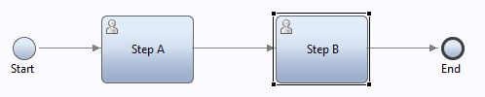

It shows two tasks to be executed one after the other.

它显示了两个联系执行的任务。

If we assume that the second task has the assignment set to "Last User in Lane" then what we are requesting is that the user who completed Step A will be the user who works upon Step B.

我们假设第二个任务被分配给"车道上的最后一个用户"然后我们的要求完成Step A 的用户同时完成 Step B 的任务

We may now wish the process to automatically proceed to show the user (who completed Step A) the screen for Step B

我们希望Step A （Step 已经完成）的用户立刻自动显示到Step B的屏幕上。

Explicitly,we don't see a need to have the user go back to the task list and manually open the task.

也就是说，我们不需要用户返回任务列表手动的打开任务。

We can achieve this by the use of the "Automatically flow to next task" check box set in Step A.

我们可以通过在Step A 中的 "Automatically flow to next task" 复选框来实现这个功能。

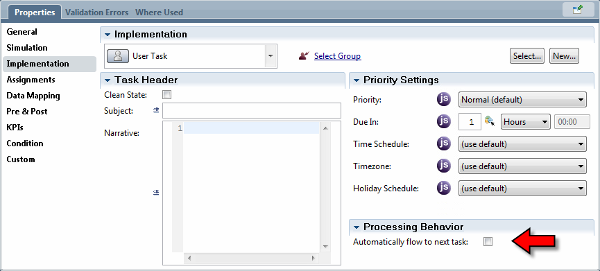
If checked, when Step A is completed, we now show the next task for that user.

如果选中"Automatically flow to next task" 复选框，当Step A完成后我们会立刻为用户显示下一个任务。

There are some constraints to this, specifically, the next task for the user in the same process must be available within a finite period of time.

有一些限制条件，特别是在一个相同的流程下，用户下一个任务必须在一个有限的时间内完成。

The default is three seconds. This is configured by the "autoflow-timeout" parameter set within the 99Local.xml configuration file

默认的是三秒。这是通过配置文件99Local.xml中的"autoflow-timeout" 参数设置的

Experimentation has shown that almost any activity between one Human Activity and the next will break the association. It appears that only simple decisions will allow auto flow to work.

实验表明，几乎所用的活动都是在一个Human Activity 和一个即将中断的协会中。看来只有简单的决议才适合使用自动流。

An interesting use case for the auto flow capability is to place logic between the tasks such as is shown in the next image:

一个关于在两个使用了自动流功能的用户任务之间添加一些逻辑的例子如下图所示：
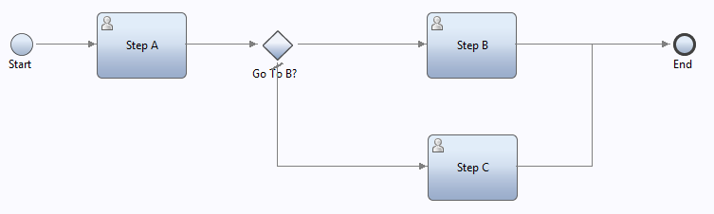

Here we assume that something entered in Step A is used as a determinant as to whether Step B or Step C should be shown next.

这里我们假设在Step A中有一个参数来判断下一步是显示Step B还是 Step C.

Assigning Activities – Mapping staff to work 活动分配-职员工作的制定
For human activities, a basic question comes to mind … which users should be eligible to perform the work?

一个关于Human activities最基本的问题，什么用户有权限执行这个操作？

Not all employees in an enterprise have the same roles and responsibilities

在一个企业中并不是所有的员工的角色和责任都是相同的。

For example, if I request the purchase of a new laptop within IBM, it should be a member of the procurement department that should handle that request and not, for example, someone in the advertising department.

例如，我有个需求在IBM里面采购一台新的笔记本电脑，应该由采购部门的人处理这个需求而不是广告部的人。

Assigning work to the correct people not only results in work being responded to in a timely fashion (if at all) but also has important implications with respect to security.

分配工作给正确的人不仅仅是为了尽快的获得结果还要包含重要的安全方面的考虑

For example, if we are bringing a new employee into our company, the request for salary information may be desired to be processed by someone in human resources and the details of that request should not be visible to others (for example staff in the new employee's same team).

例如,一个新员工入职，薪资信息要求必须由人力资源部的人处理并且详细信息 不能让其他人知道（例如，员工团队中的新成员）

Another consideration is that of balancing workload. If a department has three staff members and
two are idle while the third has more work requests than he is able to handle, this is also not a good situation.

另外一个要考虑到的是，平衡工作量。如果一个部门有三个员工，有两个是闲着的而第三个需要处理更多的需求，这是一个不好的情况。

To provide answers for these considerations, task assignment can be performed through the Assignments tab in the Process Designer section while editing a human step.

提供以上考虑的解决方案，在编辑人员步骤的时候可以通过Process Designer 部分的Assignments 标签来实现任务的分配。

By default, an activity is assigned to the set of users defined in the Team of the lane in which the activity is placed.

默认情况是，一个活动的分配是在当前活动的轨道的团队中的用户定义中设置的

The selection of assignment for an activity may be modified by changing the Assign To definition of the activity as found in the Assignments tab in the properties view:

选择一个活动的分配可以通过改变properties视图中的Assignments标签下的
Assign To 的定义活动。

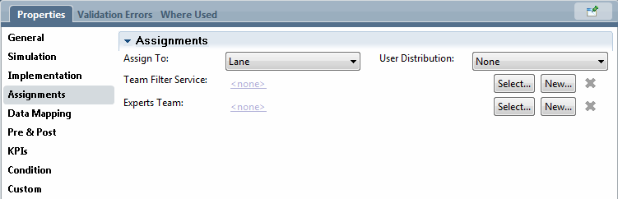

The Assign To property is a pull-down list that defines the selection criteria used to select which people are eligible for the activity.

Assign To 属性是定义的是一个所有参加活动的用户都有权限使用的下拉列表

It may have one of the following options:

它可以使下面的选项之一：

Lane – This is the default selection. In this mode, the activity is assigned to the Team associated with the lane in which the activity is placed. The activity can then be owned by one of the members of that Team.

Lane - 这是一个默认的选项。在这种模式下，活动被分配在有活动车道的团队中。活动可以由一个团队成员拥有。

Team – An explicitly selected Team will be selected to own this task.

Team- 选中Team选项就是选择自己的任务。

When this option is selected, a new entry for the Team to be chosen will be shown.

该选项被选中后，Team将显示一个新的入口

A team can then be selected from the list of available defined Teams.

然后，Team可以选中从有效地团队列表中选择一个团队。

xxxxx
An alternative to explicitly naming the team is to reference a String variable that will hold the name of the team.

Last User in Lane (Deprecated) – Since this option has been deprecated in the current release of the product, no further discussion on it will be made.

Last User in Lane (Deprecated) - 由于该选项在当前版本中被废弃掉，所以不讨论它的使用。

Routing Policy (Deprecated) – Since this option has been deprecated in the current release of the product, no further discussion on it will be made.

Routing Policy (Deprecated) - 由于该选项在当前版本中被废弃掉，所以不讨论它的使用。

• List of Users (Deprecated) – Since this option has been deprecated in the current release of the product, no further discussion on it will be made.

List of Users (Deprecated) –由于该选项在当前版本中被废弃掉，所以不讨论它的使用。

• Custom (Deprecated) – Since this option has been deprecated in the current release of the product, no further discussion on it will be made.
Custom (Deprecated) - 由于该选项在当前版本中被废弃掉，所以不讨论它的使用。

Both the Lane and Team options also have the concept of a "Team Filter Service".

车道和团队的等选项也需要 "Team Filter Service" 有的概念

This is an optional service which takes as input a Team data structure and returns a new Team data structure.

选中的service作为一个输入的团队数据结构并返回一个新的团队的数据结构

This is an optional service which takes as input a Team data structure and returns a new Team data structure.

选择的团队成员作为输入，否则将被分配工作

The output is presumed to be a subset of those team members dynamically selected to perform the work.

输出被认为是这些团队成员被动态选择执行工作的一部分

This effectively allows us to filter the team members. If no team filter service is supplied, the original selection of team members will be used.

允许我们过滤出有效地团队成员，如果不提供团队过滤服务，将会选中使用原来的团队成员。

It is anticipated that the filtering of team members may need additional parameters in order to make its decision.

需要知道的是团队成员的过滤需要在决议规则中添加额外的参数。

For example, the staff members necessary to perform a procurement may be chosen from the procurement department dependent on whether it is hardware or software that is being ordered.

例如，执行采购需要由采购部门根据硬件还是软件安排必要的人员采购。

The team filter service can be supplied additional parameters in its definition. If additional parameters are defined, these will be available to be mapped in the Assignments area:

团队过滤服务可以提供额外的参数的定义。如果定义了额外的参数，将在分配的区域做映射：

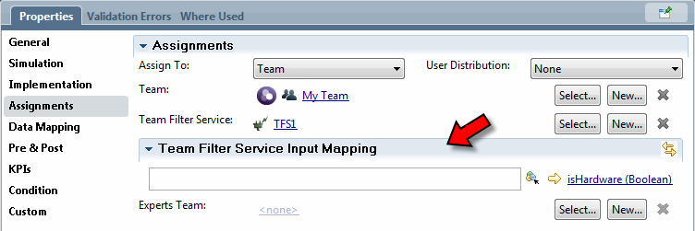

在团队过滤详情中我们可以看到，有一个"originalTeam" 类型的输入参数和一个 "filteredTeam" 类型的输出参数。

When looking in detail at a Team Filter service, we find that it has an input parameter called
"originalTeam" of type Team and it also has an output parameter called "filteredTeam" also of
type Team.

我们要先将包含在分配中的的"filteredTeam" 类型的团队成员填充到service 中。

It is expected that the service will populate the "filteredTeam" structure with the team members to be included in the assignment.

注意使用原来的团队作为输入。
Take care when using the originalTeam as input.

"members" 属性是团队成员列表的字符串描述。

The "members" property is a list of Strings describing the members of the team.

我们不知道一个成员是一个简单的用户还是一个用户组。

We don't know if a member is a simple user or a group of users.

因此，如果我们希望在用户满足特定条件的情况下循环每一个用户我们需要防御式编程。

As such, we may need to code defensively if we wish to iterate over each user to see if they
meet a specific criteria.

下面提供给定的团队中所用用户的一种算法。
Here is an algorithm that will give us all users in a given team:

// Create the resulting empty list
var users = new Array();
// Iterate over each member of the team. A member may be a user or it may be a
Role (Group)
for (var i=0; i<tw.local.team.members.listLength; i++) {
var currentMember = tw.local.team.members[i];
// Try and get the member as a user. If we find one, add it to the user list
var currentUser = tw.system.org.findUserByName(currentMember);
if (currentUser != null) {
users.push(currentUser);
} else {
// Try and get the member as a Role. If we find a match, add all the users in
the role to the user list
var currentGroup = tw.system.org.findRoleByName(currentMember);
if (currentGroup == null) {
log.info("Problem: Unable to find a user or group called " +
currentMember);
} else {
var allUsers = currentGroup.allUsers;
for (var j=0; j<allUsers.listLength; j++) {
users.push(allUsers[j].name);
}
} // We have a good group
} // Process as a group
}
// Return the list of users we found.
tw.local.users = users;
// End of script

同样在选择参数区域的第二个下拉列表"User Distribution"属性中选择一个所有以前的类型分配。
A second pull-down on the same preferences area available to all the previous types of assignment
choices is called "User Distribution".

此选项决定在一组用户中哪些用户应立即指派任务。

This option determines which users from within a set of users should be immediately assigned the task.

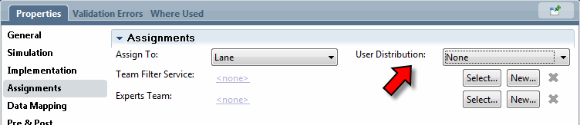

这些选项有：

The options are:

None –这是默认值。IBPM 给团队所用的成员分配任务。
• None – This is the default. IBPM assigns the task to all members of the Team.

Last User –在这种模式下，将任务分配给在同一个泳道上的最后一个用户。
Last User –In this mode, the user selected is the last user that had a task in the same swim Lane.

Load Balance – 在这种模式下，将任务分配给打开任务最少的团队成员。
• Load Balance – In this mode, the task is assigned to the member of the Team who has the
fewest number of open tasks.

Round Robin –在这种模式下，将任务分配给按顺序排列的方式的团队成员。
• Round Robin – In this mode, the task is assigned to a member of the Team in a serial
fashion.

例如，如果一个团队中有三个成员，第一个任务分给第一个成员，第二个任务分给第二个成员，第三个任务分配给第三个成员。到第四个任务的时候，又分配给第一个成员。
For example, if the Team has three members, the first time a task is assigned, it will
be assigned to the first member, the next task to the second and the third task to the third
member. When the fourth task is to be assigned, it will be assigned to the first member again.

请参阅：
See also:
• Security
• Teams
• Vimeo - IBM BPM 8.5 Teams
• DeveloperWorks - Common business process modeling situations in WebSphere Lombardi Edition V7.2, Part 1 - Role-based and dynamic
routing of activities

改变小组成员重新分配任务
Re-Assigning Tasks and changing group members

假定一个包含活动的团队PD实例。
Imagine a BPD instance which includes an activity associated with a team.

如果一个团队与外部的系统组关联如果在断言之前系统做的成员关系改变那么会创建一个新的任务吗？
If the team is associated with an external system group then what will happen if the system group's membership changes after the creation of a task but before it is claimed?

答案是任何已经被创建的任务将成为改变的新组。
The answer appears to be that any tasks already created will honor the new group change.

遗憾的是，不能再这个任务创建之后组成一个新的团队
Unfortunately, there does not appear to be a way to change the makeup of a team after the task is created.

所以，创建一个任务会设置一个特定所有者，由这个所有者来修改任务（除非它们来自同一个系统组）
So if a task is created with a certain set of potential owners those potential owners are fixed to that task (unless they come from a system group).

任务实例
Assignment Examples

下面是一些用户分配的实例。

Here are some examples of some of the more interesting assignment uses.

The Four Eyes Example
在一些过程中，两名工作人员审查或批准的一些活动。
There are some processes where two staff members have to review or approve some activity.
例如，让我们想想IBM硬件采购。如果我，作为一个IBM的员工，希望一个新的笔记本电脑，我可以把我的请求提交到采购部门。
As an example, let us think about hardware procurement at IBM. If I, as an IBM employee, wish a new laptop, I can submit my request to my procurement department.

请求必须有两位采购专家的审查的流程。
Their process says that the request must be reviewed by two procurement specialists.

我们假设在IBPM中实现这个流程。
We can imagine this being implemented in IBPM.

人工服务来执行分配给采购人员的请求。
A Human Service would be executed that assigns the request to anyone in the Procurement
group.

如果请求被批准我们立刻第二个人工服务也分配到采购组。
If the request is approved we now create a second Human Service and assign that also to the
Procurement group.

遗憾的是，这个解决方案有一个问题。
Unfortunately, there is a problem in that simple solution.
如果第一个任务分配给采购组的"Bob"来完成这个工作，同时第二个任务也将会被分配给采购组的"Bob"。
If the first task is assigned to the Procurement group and "Bob" works on it, the second task will also be assigned to the Procurement group and, unfortunately, there is nothing to prevent "Bob" from working upon and claiming that second task as well.

这个任务是由采购组的某个人处理的，只是每一次都是同一个人这不是我们的意图。

The tasks "have" been handled by "someone" in the Procurement group … it just was the same person each time and that is not the intent of our story.

幸运的是，这里有一个相对比较容易的解决方案。我们应该像这样建立流程。

Fortunately, there is a relatively easy solution. We build a process that looks like this.

